

NATIONAL ECONOMIC CONSULTATIVE FORUM

MONTHLY ECONOMIC BULLETIN

AUGUST 2024

Executive Summary
This bulletin focuses on economic developments for the month ending 31 August 2024 that include: World economic developments, international commodity prices, Zimbabwe Gross Domestic Product (GDP) growth updates, merchandise trade developments, exchange rate developments, inflation developments, monetary developments and stock market developments.
Global economic growth is expected to slow from 3.3% in 2023 to 2.9% in 2024 and further to 2.7% in 2025, according to projections by Wells Fargo Economics that are in line with those of the IMF although they differ in magnitude. The slowdown is driven by rising recession risks in the United States and a downturn in key developing economies, particularly China. This global outlook is impacted by intensifying geopolitical tensions and the potential for higher interest rates, with overall growth expected to remain below the historical average of 3.8%. Global inflation is projected to decrease significantly from 6.8% in 2023 to 3.6% in 2024, supported by tighter monetary policies and lower commodity prices, providing an opportunity for Zimbabwe to suppress imported inflation and achieve its single-digit inflation target.
Meanwhile, selected commodity prices showed mixed performance. While crude oil, copper, and soybean prices declined by 4.84%, 0.75%, and 4.85%, respectively, metals like aluminum, copper, and gold saw year-on-year gains of 9.39%, 8.28%, and 29.11%, respectively. El Niño-induced droughts and export restrictions in key exporting countries contributed to the rise in prices for some commodities. However, the decline in agricultural commodity prices is concerning for Zimbabwe’s agricultural sector, which remains vulnerable to external shocks and price volatility.
Zimbabwe’s economic growth forecast remains at 2% for 2024, with the economy facing significant challenges from the El Niño-induced drought. Agricultural output, a key driver of GDP, is expected to be negatively impacted, necessitating close monitoring of economic developments by the NECF Policy Analysis Section.
Zimbabwe’s merchandise trade recorded a decline in June 2024, with total trade falling to USD 1.27 billion, down 3.7% from May 2024. The trade deficit widened to USD 218.9 million, primarily due to a drop in gold prices and reduced exports. Year-on-year, trade volumes fell by 7.3%, reflecting broader economic challenges. The increase in the import bill highlights the need for measures to boost exports and reduce the country’s dependency on imports, especially for essential goods.
The Zimbabwean dollar (ZWG) continued to depreciate against major currencies in August 2024, losing 0.6% against the USD, 3.08% against the GBP, 2.86% against the EUR, and 3.6% against the ZAR. The parallel market rate showed some stability, with a decrease in the market premium from 81% to 66%, although this remains too high for meaningful convergence between the official and parallel market exchange rates. The USD's depreciation against regional currencies, particularly the ZAR, provides opportunities to enhance Zimbabwe’s exports to South Africa.
Meanwhile, the country experienced a rise in both ZWG inflation and weighted inflation, though the increases differed in magnitude. ZWG inflation surged to 1.4%, up from -0.1% in July, driven by higher prices in key categories such as food, non-alcoholic beverages, housing, and utilities, reflecting the impact of local currency depreciation and cost-push inflation. In contrast, weighted inflation, which factors in both local and foreign currency prices, increased more moderately to 0.4% from -0.1%, indicating relative stability in goods and services priced in foreign currency. This divergence suggests that foreign currency transactions are helping to mitigate overall inflationary pressures in Zimbabwe’s multi-currency economy.
Broad money supply in Zimbabwe increased by 4.14% from May to June 2024, reaching ZWG 42.73 billion. Foreign currency transferable deposits made up 70.67% of the money supply, reflecting the dominance of foreign currency in the economy. Local currency deposit rates ranged from 3.75% to 3.88%, while lending rates were significantly higher at 24.57% to 30.60%, potentially stifling borrowing and investment in the local currency. The relatively lower interest rates on foreign currency loans may incentivize export-oriented businesses to expand, although the disparity between local and foreign currency lending rates could create challenges for businesses reliant on local currency financing.
The Zimbabwe Stock Exchange (ZSE) recorded mixed performance in August 2024, with the All-Share Index and market capitalization increasing by 1.19% and 1.32%, respectively. However, the Top 10 Index and value traded fell by 2.58% and 84.51%, respectively, indicating low investor activity. On a year-to-date basis, the All-Share Index recorded a 6.57% decline. The Victoria Falls Stock Exchange (VFEX) exhibited bearish performance, with declines across key indicators on a month-on-month basis, although it remains a critical platform for attracting foreign investment in the future.
Overall, while Zimbabwe’s economic outlook is constrained by both global and domestic factors, careful management of inflation, exchange rate dynamics, and policy interventions aimed at boosting exports and stabilizing the local currency are essential for maintaining economic stability and growth.
Table of Contents
Executive Summary i
1.0 World Economic Developments 1
1.1 World Output 1
1.2 Global Inflation Developments 1
2.0 International Commodity Prices 2
3.0 Zimbabwe GDP Growth Update 3
4.0 Merchandise Trade Developments 3
5.0 Exchange Rate Developments 4
5.1 ZWG Exchange Rate Developments 4
5.2 Parallel Market Developments 4
5.3 Cross Rate Developments 5
6.0 Inflation Developments 5
7.0 Monetary Developments 7
7.1 Money Supply 7
7.2 Interest Rates 8
8.0 Stock Market Developments 9
8.1 Zimbabwe Stock Exchange 9
8.2 Victoria Falls Stock Exchange 9
9.0 Recommendations 9
10.0 References 12

List of Tables
Table 1: Global Economic Growth Developments 1
Table 2: Commodity Price Movements – Month Ending 30 August 2024 3
Table 3: ZWG Exchange Rate Movements – Month Ending 30 August 2024 4
Table 4: USD Exchange Rate Movements – Month Ended 30 August 2024 5
Table 5: Monthly Inflation for August 2024 7
Table 6: Interest Rates as at 16 August 2024 8
Table 7: Zimbabwe Stock Exchange Movements 9
Table 8: Victoria Falls Stock Exchange Movements 9

List of Figures
Figure 1: Global Inflation Prospects 2
Figure 2: Merchandise Trade Developments 4
Figure 3 : Parallel Market Developments - August 2024 5
Figure 4: Month-on-Month ZWG Inflation Outturn 6
Figure 5: Month-on-Month Weighted Inflation Outturn 6
Figure 6: Broad Money (M3) Supply 7

1.0 World Economic Developments

1.1 World Output
1.1.1 According to the Wells Fargo Economics (WFE) International Economic Outlook August 2024 Update, the Global economic growth is projected to slightly slowdown from 3.3% in 2023 to 2.9% in 2024 and further slow down to 2.7% in 2025 as shown in Table 1. The downward forecast was due to rising recession risks in the United States and an overall downturn in developing economies especially China.
Table 1: Global Economic Growth Developments
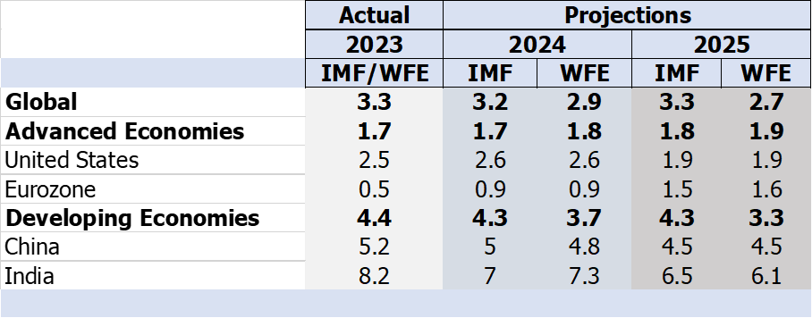
Sources: IMF, WEO July 2024 update and Wells Fargo Economics (2024)
1.1.2 The projections by WFE International Economic Outlook August 2024 Update 2024 are analogous to the International Monetary Fund (IMF) World Economic Outlook (WEO) July 2024 Update as shown in Table 1. However, the projections are below the historical average growth of 3.8% due intensifying geopolitical tensions and the possibility of higher interest rates.

1.2 Global Inflation Developments
1.2.1 Global Consumer Price Index (CPI) is projected to slow down from 6.8% in 2023 to 3.6% in 2024 similar to IMF’s projections (see Figure 1) (Wells Fargo Economics 2024). In terms of outlook, both the WFE and IMF expect global inflation to further slowdown due to tighter monetary policies and lower international commodity prices.
1.2.2 The trend inhibited by global inflation provides an opportunity for Zimbabwe to suppress imported inflation and achieve its single-digit inflation target.

Figure 1: Global Inflation Prospects
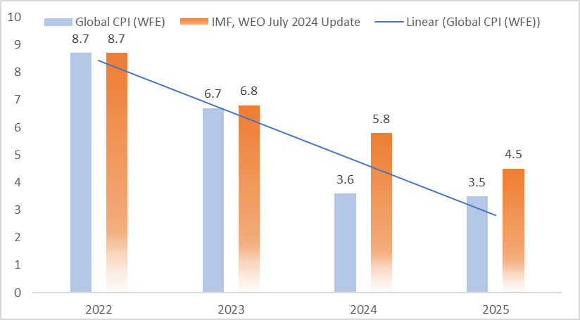
Source: IMF (2024) and Wells Fargo Economics (2024)

2.0 International Commodity Prices
2.1 In August 2024, majority of the selected commodity prices recorded an upward trend, notwithstanding a fall in crude oil, copper and soybeans prices by 4.84%, 0.75% and 4.85%, respectively (see Table 2). According to FEWS NET (2024) the increase in commodity prices was driven by supply concerns in major exporting countries related to El-Nino induced drought and continued export restrictions.
2.2 On a year-to-date basis (YtD) basis, natural gas, aluminum, copper, nickel, and gold prices gained while crude oil, cotton, soybeans, corn and wheat prices recorded a price decline.
2.3 On a year-on-year (YoY) basis, some of the selected commodity prices exhibited a negative trend though aluminum, copper and gold prices gained by 9.39%, 8.28% and 29.11% respectively. Crude oil, natural gas, nickel and agricultural commodities recorded a price decline on YoY basis. Agricultural commodities price movements on YtD and YoY basis are discouraging for Zimbabwe agricultural sector.
Table 2: Commodity Price Movements – Month Ending 30 August 2024
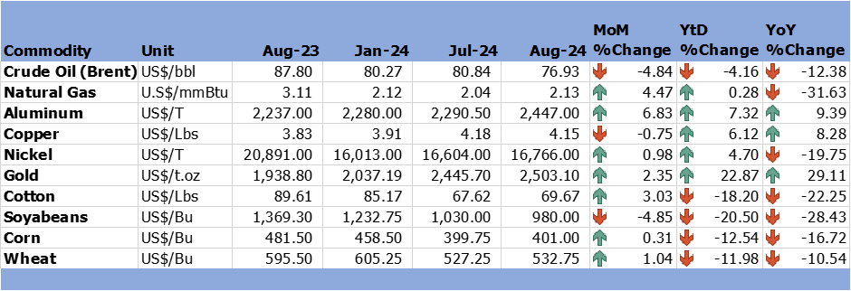
Source: Trading Economics (2024)

3.0 Zimbabwe GDP Growth Update
3.1 Zimbabwe economic growth prospects remain unchanged at 2% in 2024 as the economy is grappling with the effects of the El-Nino induced drought. The NECF Policy Analysis section will continue monitoring developments and advice accordingly.

4.0 Merchandise Trade Developments
4.1 Zimbabwe National Statistics Agency (ZimStat) had not published the merchandise trade data for August 2024 by the time of compiling this report, thus the analysis is based on June 2024 data.
4.2 In June 2024, total merchandise trade amounted to USD1268.3 million, a 3.7% decline from the USD1317.2 million recorded in May 2024 mainly due to a reduction in exports. On a YoY basis, merchandise trade fell by 7.3% from USD1368.5 in June 2023 (RBZ Monthly Report for June 2024).
4.1 As of June 2024, the country’s trade deficit stood at USD218.9 million, which was higher than the USD156.8% million recorded in May 2024. This is mainly attributed to fall in commodity prices of gold. The import bill stood at USD743.6 million in June 2024 reflecting a 0.5% increase from USD739.8 million recorded in May 2024 (see Figure 2).

Figure 2: Merchandise Trade Developments
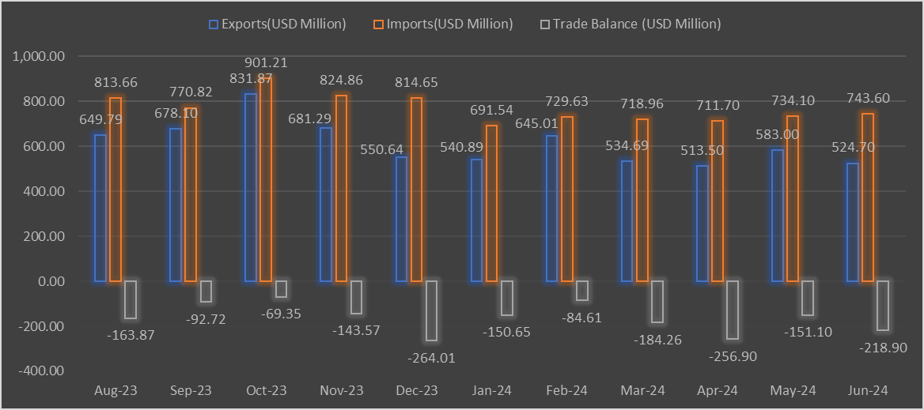
Source: RBZ (2024)

5.0 Exchange Rate Developments

5.1 ZWG Exchange Rate Developments
5.1.1 During the month under review, the ZWG depreciated against all major currencies as shown in Table 4. On a MoM basis, the ZWG lost by 0.6%, 3.08%, 2.86% and 3.6% against the USD, GBP, EUR and ZAR, respectively. The ZWG also lost value against the USD, GBP, EUR and ZAR both on YtD and YoY (see Table 4).
Table 3: ZWG Exchange Rate Movements – Month Ending 30 August 2024
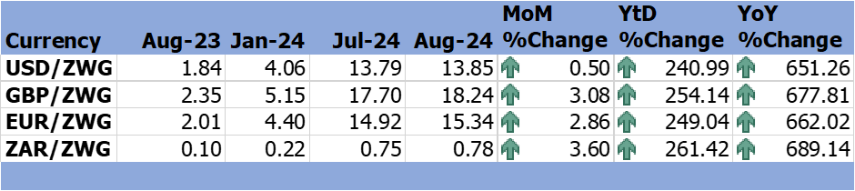
Source: RBZ (2024)

5.2 Parallel Market Developments
5.2.1 During the month under review, parallel market rate fluctuated from USD/ZWG25 to USD/ZWG23 resulting in a decrease in market premium from 81% to 66% (see Figure 3). Although the market premium declined, the 66% is too high it inhibits the opportunity for convergence between the official and the parallel market exchange rates.

Figure 3 : Parallel Market Developments - August 2024
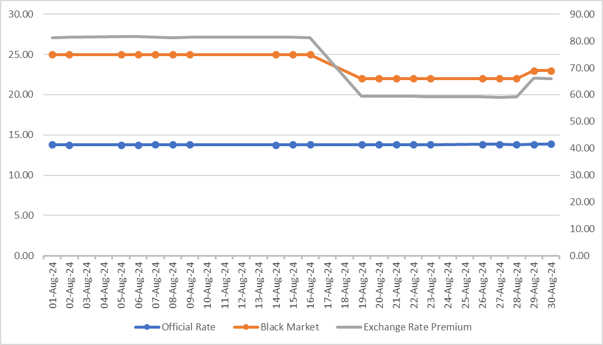
Source: RBZ and Harare Streets (2024)

5.3 Cross Rate Developments
5.3.1 During the month under review, the USD lost value against the GBP, EUR and ZAR on both MoM, YtD and YoY. On a MoM basis, the USD lost by 2.5%, 2.3% and 2.99% against GBP, EUR and ZAR respectively (see Table 4). The depreciation of the USD is due to the rising recession risks in the United States economy. Depreciation of the USD against the ZAR stimulates the country’s exports to South Africa and reduces trade deficit.
Table 4: USD Exchange Rate Movements – Month Ended 30 August 2024
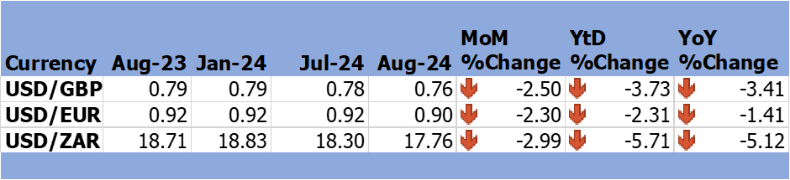
Source: RBZ (2024)

6.0 Inflation Developments
6.2 In August 2024, ZWG inflation rose to 1.4% up from -0.1% in July 2024 (see Figure 4).

Figure 4: Month-on-Month ZWG Inflation Outturn
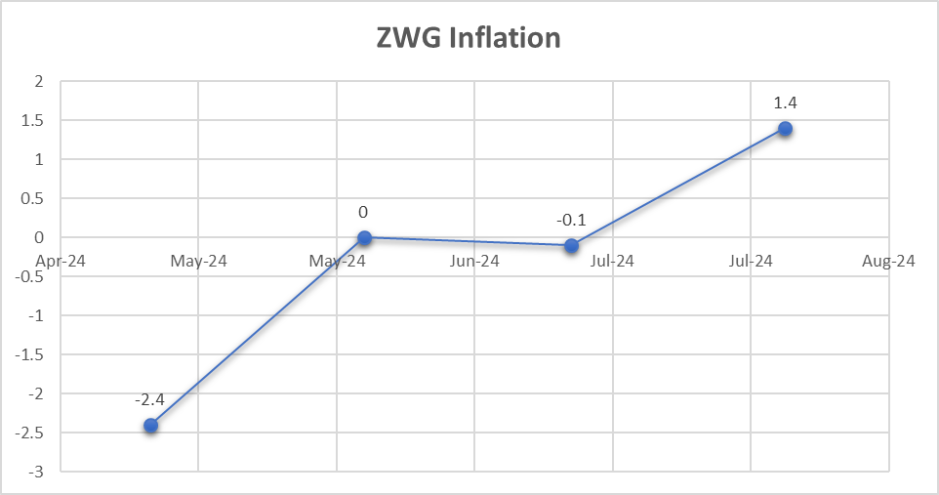
Source: ZimStat (2024)

6.2 Regarding weighted inflation, in the month of August, weighted inflation increased to 0.4% from -0.1% recorded in July 2024 (see Figure 5).
Figure 5: Month-on-Month Weighted Inflation Outturn
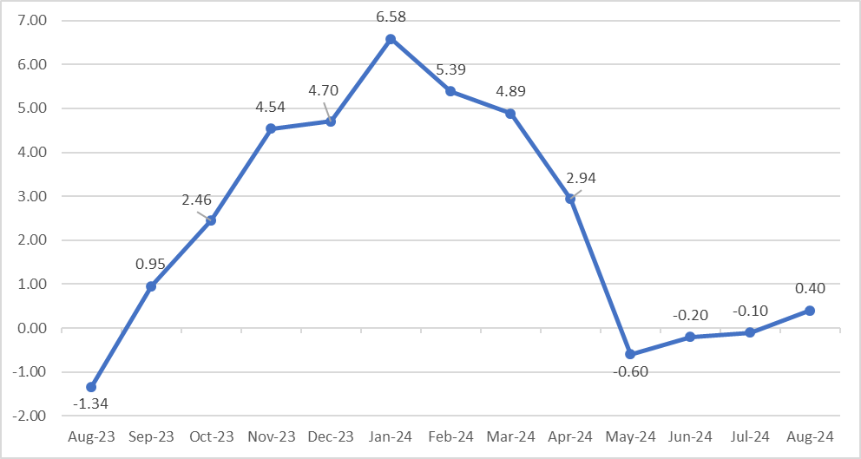
Source: ZimStat (2024)
6.3 The main contributors to both weighted and ZWG inflation are food and non-alcoholic beverages and housing, water, electricity, gas and other fuels with weights of 31.3 and 27.62 respectively (see Table 5).
Table 5: Monthly Inflation for August 2024
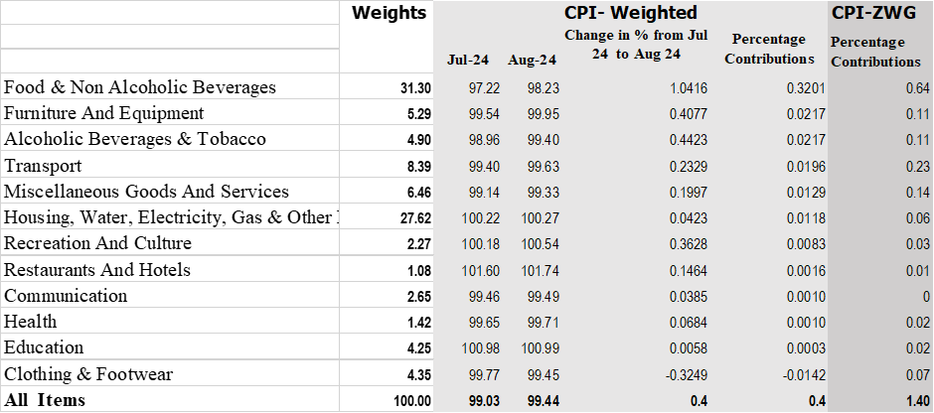
Source: ZimStat (2024)

Monetary Developments

7.1 Money Supply
7.1.1 According to the RBZ June 2024 Monthly Economic Review, broad money stock stood at ZWG42.73 billion, representing a 4.14% growth from the ZWG41.03 billion recorded in May 2024 (see Figure 6). During the same period in 2023, broad money supply stood at ZWG5.71 billion. Broad money supply was made up of 70.67% foreign currency transferable deposits, 0.12% currency in circulation, 0.01% NCDs, and 1.12% local currency time, 7.82% foreign currency time deposits and 20.26% local currency transferable.

Figure 6: Broad Money (M3) Supply
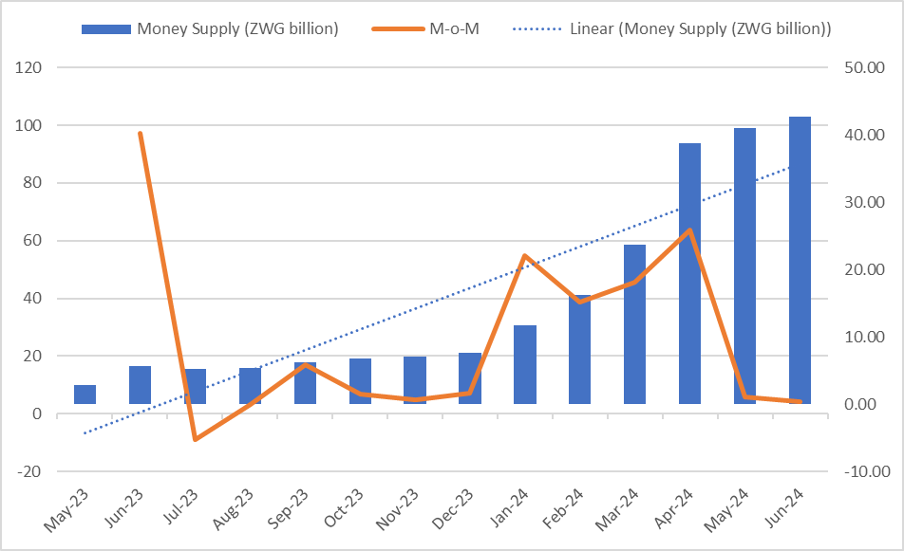
Source: RBZ (2024)

7.2 Interest Rates
7.1.1 According to the RBZ August 2024 Weekly Economic Highlights, the average commercial bank deposit rates for savings (ZWG) ranged from 3.75% to 3.88% while for foreign currency ranges from 1.53% to 1.86%. Commercial bank weighted lending rate (ZWG) ranged from 24.57% to 30.60%, while for foreign currency ranged from 10.91% to 15% (see Table 6).
Table 6: Interest Rates as at 16 August 2024
 |  | Minimum (%) | Maximum (%)
Average Commercial Bank Deposit Rates | Local Currency | 3.75 | 3.88
Average Commercial Bank Deposit Rates | Foreign Currency | 1.53 | 1.86
Commercial Banks Weighted Lending Rates | Local Currency | 24.57 | 30.60
Commercial Banks Weighted Lending Rates | Foreign Currency | 10.91 | 15
Source: RBZ (2024)
7.1.2 Low deposit rates for both local and foreign currency suggest that commercial banks are not aggressively competing for deposits. Such low rates may lead to reduced savings mobilization, as the opportunity cost of holding liquid assets becomes high.
Households and businesses might opt to invest in real assets or foreign currency holdings rather than keep money in savings accounts.
The higher rates for local currency deposits compared to foreign currency show the commercial banks’ attempt to encourage saving in the local currency, however the gap is not significant enough to offset depreciation risks.
7.1.3 The high lending rates for local currency could stifle borrowing and investment. For businesses, especially small and medium enterprises, these rates are likely prohibitive, leading to a preference for foreign currency loans, despite the challenges in obtaining foreign currency.
Furthermore, the disparity between local and foreign currency lending rates might create a dual economy within the financial sector, where businesses dealing in foreign currency (such as exporters) have access to cheaper credit, while those dealing primarily in local currency face high financing costs.
High borrowing costs in ZWG may hinder economic growth, particularly in sectors reliant on local currency financing. However, the lower foreign currency rates may boost investment in export-oriented sectors, as businesses with access to foreign currency benefit from more affordable credit.

8.0 Stock Market Developments

8.1 Zimbabwe Stock Exchange
8.1.2 During the month under review, All-Share Index and market capitalization gained by 1.19% and 1.32%, respectively. On the other hand, the Top 10 Index lost and Value Traded lost by 2.58% and 84.51%, respectively, as shown in Table 7.
8.1.3 On YtD, All Share Index lost by 6.57% and value trade lost by 86.98%. Top 10 Index and market capitalization gained by 112.16% and 258.96% respectively. All indices gained on YoY basis.
Table 7: Zimbabwe Stock Exchange Movements
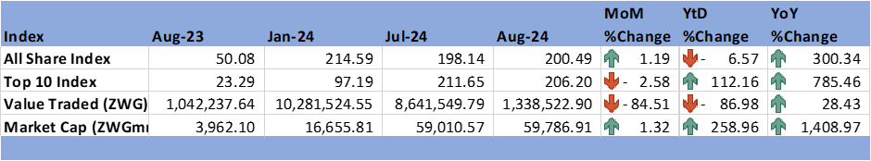
Source: ZSE (2024)

8.2 Victoria Falls Stock Exchange
8.2.1 The Victoria Falls Stock Exchange recorded a bearish trend in August 2024. On MoM basis, the All-Share Index, Value Traded and market capitalization lost by 1.14%, 30.9% and 2.59% respectively (see Table 8).
8.2.3 On YtD and YoY basis, All-Share Index and market capitalization gained except Value Traded which lost by 38.75% on YtD.
Table 8: Victoria Falls Stock Exchange Movements
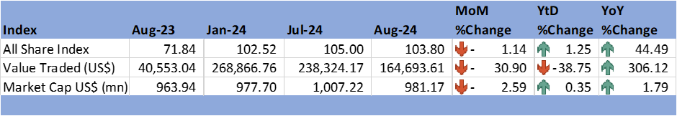
Source: VFEX (2024)

9.0 Recommendations
9.1 The following recommendations are being proposed:
9.1.1 Economic Diversification: With global growth projected to slow down, the country should intensify efforts to diversify its economy. This will help cushion the impact of lower demand from key trading partners such as China and the U.S., which are expected to experience slower growth. Sectors like agriculture, mining, and manufacturing should be prioritized, along with emerging sectors like information technology and renewable energy.

9.1.2 Boost Agricultural Resilience: Given the El Niño-induced drought and the discouraging price movements in agricultural commodities, the country should enhance agricultural resilience by promoting climate-smart agriculture, investing in irrigation infrastructure, and improving drought-resistant crops. This will mitigate the effects of climate change on the agricultural sector and ensure food security.

9.1.3 Export-Oriented Industrialization: With the depreciation of the USD against the ZAR, there is an opportunity to boost exports to South Africa. The country should focus on enhancing the competitiveness of its exports, particularly in sectors like mining, manufacturing, and agri-processing, to take advantage of this currency dynamic and reduce the trade deficit.

9.1.4 Inflation Control: The projected decline in global inflation provides a window for the country to control domestic inflation. The RBZ should maintain tight monetary policy stance to ensure price stability and work towards the target of a single-digit inflation rate.

9.1.5 Monetary Policy Adjustments: The wide gap between official and parallel exchange rates calls for measures to achieve convergence. Policies to stabilize the local currency, such as bolstering foreign currency reserves, managing inflation expectations, and promoting confidence in the formal market, should be reinforced.

9.1.6 Interest Rate Policy: The high borrowing costs in local currency may stifle investment, particularly for small and medium enterprises (SMEs). The RBZ should consider revising interest rate policies to make credit more accessible, especially for priority sectors like agriculture, manufacturing, and export-oriented industries, while encouraging local currency savings by offering more competitive deposit rates.

9.1.7 Stock Market Development: The ZSE's mixed performance highlights the need for reforms to enhance investor confidence and liquidity. Encouraging wider participation, including institutional investors and retail investors, alongside offering tax incentives for stock market investments, could boost activity. Additionally, promoting the VFEX as a hub for regional and international investments will support the diversification of capital markets.

9.1.8 Addressing the Trade Deficit: The growing trade deficit suggests a need for policies aimed at boosting exports and reducing reliance on imports. Efforts should be focused on value addition for raw materials, improving trade facilitation, and signing trade agreements that can enhance market access for Zimbabwean products.

NECF Secretariat, 2024

10.0 References
FEWS NET. (2024). Global Price Watch. Famine Early Warning Systems Network .
RBZ. (2024). Exchange Rates. Retrieved from Reserve Bank of Zimbabwe: https://www.rbz.co.zw/index.php/research/markets/exchange-rates
Reserve Bank of Zimbabwe. (2024). 2024-Mid-Term Monetary Policy Review Statement. RBZ.
Reserve Bank of Zimbabwe. (2024). Monthly Economic Review: June 2024. RBZ.
Reserve Bank of Zimbabwe. (2024). Weekly Economic Highlights. Vol. 26 No. 33. RBZ.
Trading Economics. (2024). Commodities. Retrieved from Trading Economics: https://tradingeconomics.com/commodity/crude-oil
VFEX. (2024). Main Dashboard. Retrieved from Victoria Falls Stock Exchange: https://www.vfex.exchange/
Wells Fargo Economics. (2024). International Economics Outlook: August 2024. Wells Fargo.
ZimStat. (2024). Inflation Rates. Retrieved from Zimbabwe Statistics Agency: https://www.zimstat.co.zw/
ZSE. (2024). Main Dashboard. Retrieved from Zimbabwe Stock Exchange: https://www.zse.co.zw/

